The Use Of Anterior Pelvic Internal Fixator To Treat Disruptions Of The Anterior Pelvic Ring

Department of orthopedic surgery, Benha faculty of medicine ,Benha University,Egypt.
Correspondence to:
Sherif el tregy
Abdelrady R. Saleh
Email:
nmdoctor2012@yahoo.com
Abstract: In a prospective study we performed anterior internal fixator surgery to 20 patients with anterior pelvic injuries. Twelve patients only needed anterior internal fixator where the rest required additional surgical procedures for concomitant injuries. Reduction was assessed using Matta criteria and was judged to be excellent in four, good in 13 and fair in 3 patients. Using Majeed score to assess the results we had 5 excellent, 13 good and 2 fair results after removal of the anterior fixators. All patients could comfortably sit, stand, squat, lie prone, and lie on their side. Complications included infection in four patients (1 deep and required debridement, 2 superficial and 1 mild infection that responded fairly to dressing and antibiotic therapy) and three case had lateral cutaneous nerve affection and loosening in one screw in one case. and Complications had no effect on the final outcome of the procedure. We believe that internal fixator procedure to be a convenient option for treatment of anterior pelvic injuries specially bony ones.
Introduction: The anterior pelvic ring includes the pubic symphysis, pubic rami and ventral ilium, providing 30% of the pelvic stability. The posterior ring mainly comprises the sacrum, dorsal ilium, and sacroiliac joint complex, providing 70% of pelvic stability(1).
Variable options can be used for fixation of anterior unstable pelvic injuries including plating, external fixation, cross screwing and intramedullary screws. The best method for addressing such injuries remains controversial as each one has its specific merits and demerits (2).
Anterior external fixation is helpful to achieve initial hemodynamic stabilization with a shorter operating time and less blood loss than open reduction and internal fixation. There has been an increasing interest in minimally invasive plate osteosynthesis for anterior pelvic fixation with less trauma and better stability.(2) Nevertheless, neurovascular injuries may occur because of difficulty in dissection and a prolonged learning time. (3)
Internal fixator (INFIX) involves the use of a pedicle screw–rod fixator comprising two pedicle screws fixed into bilateral supra-acetabular bone and a curved rod interconnecting them subcutaneously (4).
This INFIX technique has gained popularity, over the past decade, as an alternative to external fixation because it avoids issues with pin sites and long-term discomfort, especially in morbidly obese patients. Compared with external fixation, INFIX has similar in vitro translational and superior rotational stiffness of mechanical stability (5,6)
Depending on the percutaneously introduced device to achieve internal fixation, this technique targets to combine the advantages of both internal and external fixation and avoiding the complications attributed to them.
Objectives : Our primary objective was to evaluate the efficacy of INFIX to achieve healing in anterior pelvic injuries together with the functional outcome of it and to report associated complications as possible. Our secondary aims included assessing the time for healing, operative time and blood loss during the surgery.
METHEDOLOGY: The inclusion criterion was a rotationally unstable pelvic ring injury requiring anterior fixation including pubic ramus fractures and symphyseal diastasis. The exclusion criteria were age of <18 years, Hemodynamically unstable patients who are unsuitable for surgery within 3 weeks, infection or soft tissue defects interfering with coverage of the fixation, acetabular or supra-acetabular fractures that impaired the stabilization of screw insertion and previously conservatively or surgically treated pelvic injuries.
The indications for surgical repair of posterior ring injuries were sacroiliac displacement and sacral fractures. Contraindications included sacroiliac joint disruptions combined with fractures of the dorsal ilium or sacral plexus injuries requiring open decompression.
All patients had preoperative anteroposterior, inlet and outlet pelvic radiographs and computed tomography scans including three dimensional ones. The Injury Severity Score was used to assess the severity of the injuries.
Advanced Trauma Life Support protocols (ATLS) were followed in the emergency department till the patients’ general condition is stabilized then secondary and tertiary surveys were done.
Ipsilateral skeletal or external traction was used as a temporary method for fracture reduction and pain relief. Patients were scheduled for surgery using the principals of early total care or damage control orthopedics according to their thoroughly assessed physiologic.

Surgical technique : Posterior fixation was always done first using either TIFI or sacroiliac screw(s) or Transiliac internal fixator (TIFI) prior to anterior fixation, usually in the same session.
Patient is placed in supine position on a radiolucent table and prepared and draped from above the umbilicus down to the ankles with both legs and feet separately wrapped in a sterile drape.
The anterior inferior iliac spine (AIIS) has to be localized (figure-1). It can be difficult to palpate in an obese patient where it lies 3 to 4 cm inferior to and 2 cm medial to the anterior superior iliac spine (ASIS) so its position has to be confirmed by c-arm fluoroscopy to be used to create the screw entry point.
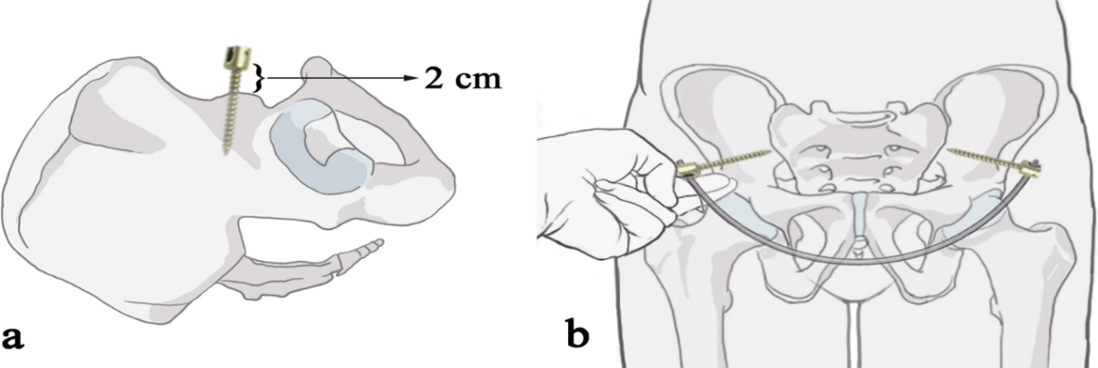
Figure -1: Graphic pictures show anatomical landmarks for INFIX application.(7)
(a) The pedicle screw head should be kept at least 2 cm from the bone surface to avoid compression of the vascular tissue after installation of the connecting rod. (b) After installing the connectting rod, the overlapped index finger and the middle finger were used to check if there was enough space between the connecting rod and bone.
An obturator outlet view helps visualization of the anterior inferior iliac spine (AIIS) as a “teardrop” (figure-2). A 4cm incision following the groin crease centered over the AIIS (figure-3) is then made with caution as the lateral femoral cutaneous nerve usually crosses the surgical field. Then Sartorius-tensor facia lata interval is bluntly dissected to provide access to AIIS.
The cortex in the middle of the AIIS is opened using a pedicle awl then a pedicle finder is used to create a tunnel directed at the posterior superior iliac spine (PSIS) taking care not to penetrate the ilium as confirmed by fluoroscopy in an obturator-inlet view.
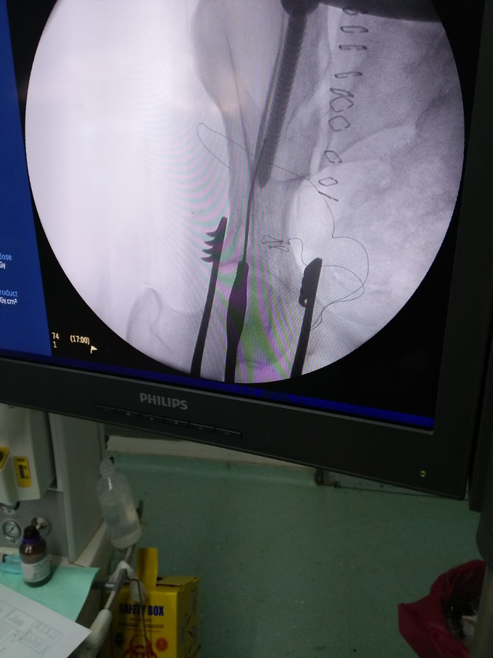
Figure-2 : Obturator-inlet view and application of pedicle finder towards PSIS.
Clearance of the hip joint and greater sciatic notch can be checked in an iliac view. The tunnel is then prepared for a pedicular polyaxial screw which ranged from 60-80 mm in length and 6.5 or 7 mm in diameter (figure-4).
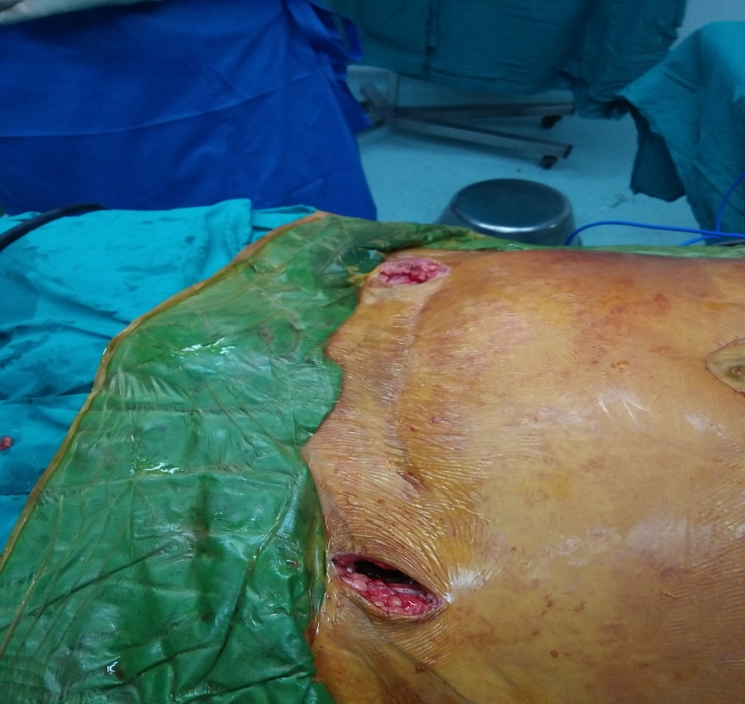
Figure-3 : Photo showing incisions for INFIX application

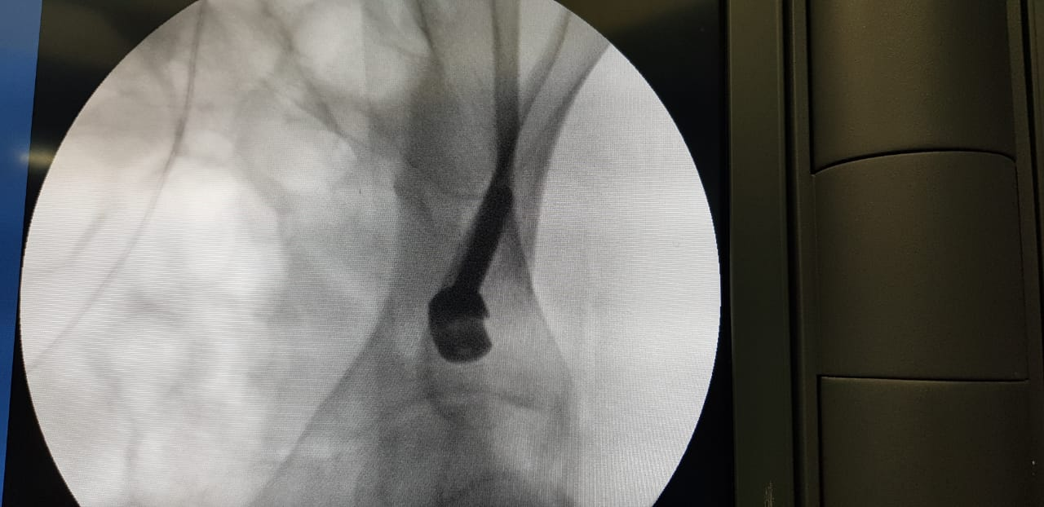
Figure-4 : Fluoroscopy picture show poly axial screw in desired position.

The same steps are done bilaterally till such a screw is placed in the desired plane then a 6mm rod is placed over the screws.
Long artery forcecps is used to make a tunnel for the connecting rod, under the superficial fascia, connecting the two incisions previously made for screws insertion. Preparation of the rod usually entails its contouring in an anteroinferior bow to avoid potential neurovascular complications if placed straight. The rod is then gently manipulated across its way through this tunnel to connect the screws together. Polyaxial screws can make this much easier and less time consuming. The screw cap should be loosely attached to retain the rod while still manipulating the rod to fit into both screws and till reduction is performed.
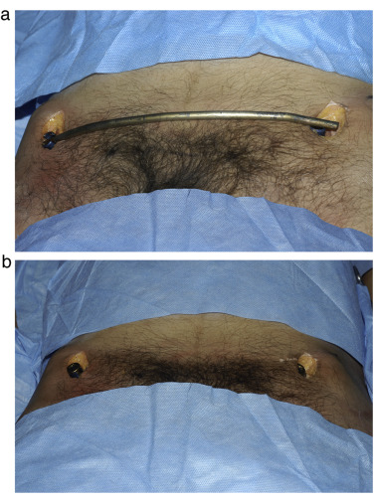 | Figure-5 : Photo show precontouring of the rod with poly axial screws placed in desired position .
We did reduction according to the existing deformity, usually in the form of manual reduction by lateral compression and, if needed, leg traction and internal rotation. Some injury patterns such as Tyle type B2, lateral compression lnjuries, required no internal rotation as actually they often need distraction instead. Reduction tools that can be attached to the screws to provide firm grip of the hemipelvises can be useful especially in obese patients and gross instabilities. Once reduction is complete and position of the connecting rod is adjusted at the desired position, the previously loosely attached screws can be tightened to hold the final position. Manual check of stability and fluoroscopic final check are done before closure of the incisions.

Post operative rehabilitation: Starting from the first postoperative day the patients were asked to start exercising their lower limbs and joints in bed. Sitting on the bedside was permitted after 2 weeks. Stitches were removed at 2 weeks postoperatively. Patients were allowed to sit, turn in bed, lie on their sides or prone even in the early post-operative period. Hence nursing care was easy, especially in the intensive care unit.
Follow-up: visits were arranged at 4 weeks, 8 weeks, 3 months, 6 months postoperatively for clinical and radiological examinations. No weight bearing was allowed before 4 weeks for patients with isolated anterior injuries and for 6 weeks for patients with associated posterior instability. The quality of pelvic ring reduction was repeatedly evaluated according to the Matta criteria, which involve grading of the maximal displacement measured on anteroposterior and inlet and outlet pelvic radiographs: excellent (0–4 mm), good (5–10 mm), fair (11–20 mm), or poor (>20 mm). Partial crutches-assisted weight bearing was allowed till evidence of healing existed if no other injury precluded that, such as other lower limb fracture. Regarding patients with fractures, union with progressive callus formation provided enough evidence of healing, while in patients with pure ligamentous symphyseal diastasis such findings do not appear. We generally recommended patients to proceed with gradual full weight bearing 3 months postoperatively as this period of time should be sufficient to attain properly stiff healing whether injuries are bony or ligamentous.
All patients had their internal fixators removed after a period of time that ranged from 4 to 8 months (mean 6 months) postoperatively as judged by their progress in the rehabilitation program and device induced symptoms.
The clinical findings before removal of the implant were assessed using Majeed score which included five functional indicators pain;30 points, sitting;10, standing;36 , sexual intercourse;4 and work;20.standing itself is subdivided into 3 sectors, walking aids, gait unaided and walking distance with 12 points for each.
Results: Our study included 20 patients with mean age of 43.85 years old with mean time of 7.95 days (1-12 days) as a period from injury to surgery and the mean time of operation was 68 minutes with mean blood loss of 128 (table-1).

Table -1: Descriptive data of the patients and the surgery
 | Mean | Median | S.D | Minimum | Maximum
Age | 43.85 | 43.5 | 6.68 | 33 | 58
Time from injury to surgery/day | 7.95 | 8 | 2.46 | 3 | 15
Operation time/min‎ | 68 | 60 | 25.45 | 40 | 120
Blood loss | 128 | 100 | 78.29 | 50 | 300

Our patients included 10 males (50%) and 10 females (50%) with 4 mechanisms of injury: 3 patients with crush injury (15%), 4 patients with direct trauma (20%), 5 patients with fall from height (25%) and 8 patients with road traffic accidents (40%). (table-2, figure-6)
Figure -6: Mechanism of injury

The Injury Severity Score was used to assess the severity of the injuries and the average score was 25 points (range, 9–50 points).
The surgical procedure that we used was essentillay the same in 12 patients (60%) who needed only INFIX, but the rest of our patients needed additional surgical procedures due to associated injury (table-3).

Table -2: Descriptive data of the patients and the surgery
 |  | No | %
Sex | Male | 10 | 50.0
 | Female | 10 | 50.0
Mechanism of injury | crush injury | 3 | 15.0
 | direct trauma | 4 | 20.0
 | fall from height | 5 | 25.0
 | traffic accident | 8 | 40.0
Associated  Injuries | brain concussion | 1 | 5.0
 | fibula+rib fracture | 1 | 5.0
 | fracture calcaneus | 1 | 5.0
 | fracture D7+base skull | 1 | 5.0
 | fracture sacrum | 1 | 5.0
 | L2 compression fracture | 1 | 5.0
 | left radial fracture | 1 | 5.0
 | lt humerus fracture | 1 | 5.0
 | lt sacroiliac+bil ankle | 1 | 5.0
 | lt subtrochanteric # | 1 | 5.0
 | posterior sacroiliac | 1 | 5.0
 | rib fracture | 1 | 5.0
 | right ulna fracture | 1 | 5.0
 | rt colle’s fracture | 1 | 5.0
 | rt shaft femur | 1 | 5.0
 | rt.hip dislocation | 1 | 5.0
 | rupture spleen | 1 | 5.0
 | subdural hematoma | 1 | 5.0
 | None | 2 | 10.0

Table-3:Surgical procedures used during surgery
Surgical procedure | No | %
INFIX | 12 | 60.0
INFIX+interlocking femur nail | 1 | 5.0
INFIX+ fixation for distal radius | 1 | 5.0
INFIX+proximal femoral nail | 1 | 5.0
INFIX+plate humerus | 1 | 5.0
INFIX+plate radius | 1 | 5.0
INFIX+sacroiliac screw | 1 | 5.0
INFIX+si screw+plate and screws | 1 | 5.0
INFIX+spinopelvic fusion | 1 | 5.0

Follow up of the patients postoeratively was concerned with: incidence and time of healing, Majeed score at the latest follow-up visit just before removal of the implant and incidence of complications.

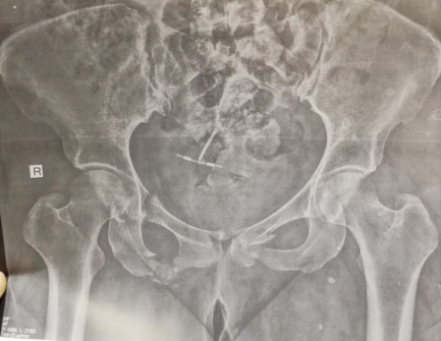 | 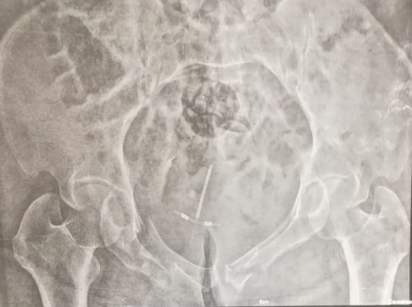 |  | 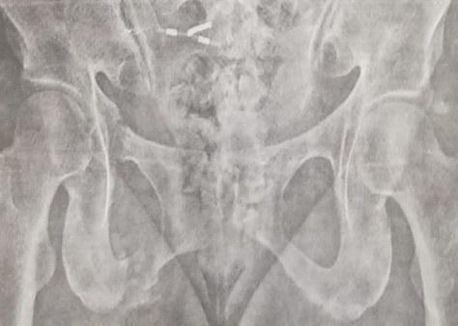
Figure-7 : Preoperative radiographs showing right fracture of both pubic rami and fracture of left pubic body.
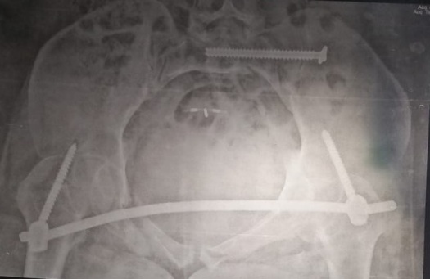 | 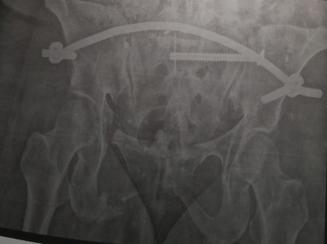 |  | Figure-8: Postoperative inlet and outlet radiographs.
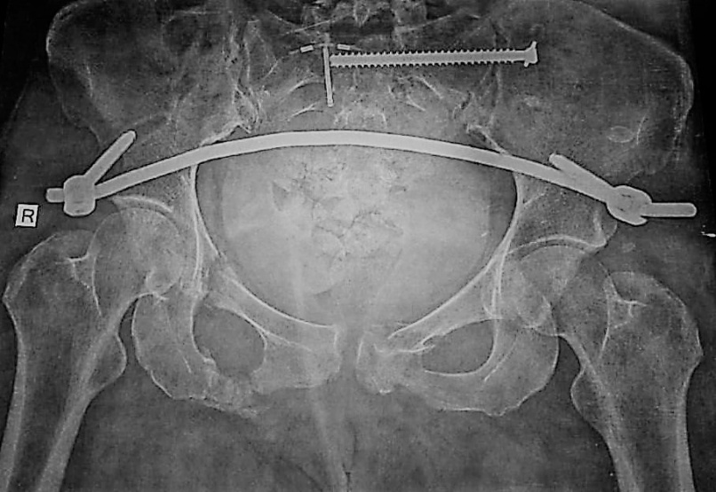 |  | Figure-9: Anteroposterior radiograph taken 2 months postoperatively showing complete union of pubic body and right inferior pubic ramus and progressive union of superior one.

In patients with anterior ring fractures (n=15), healing was indicated by appearance of callu (figure-9). All the fractures healed in mean time of 12weeks (range, 8-14 weeks). The same observations were not reproducible when assessing healing of purely ligamentous diastasis so such injuries with no subsequent displacement, pubic pain during partial weight bearing or symphyseal tenderness were considered to be healed 3 months after surgery. However 2 patients with purely ligamentous injuries had recurrent pain on full weight bearing so they they were advised to extend the use of crutches till they are pain free. One patient was pain free one month later, although she had minimal displacement during follow up (figure-13), while the other had persistent intermittent pain for three more months before becoming pain free, he had a fair reduction and no associated injuries.

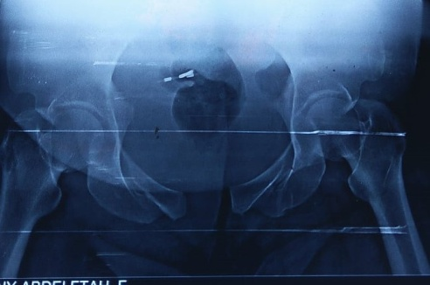 |  | 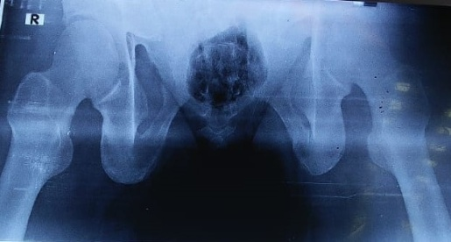 |  | Figure-10: Preoperative inlet and outlet radiographs.
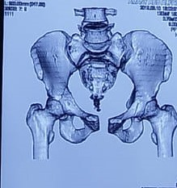 | 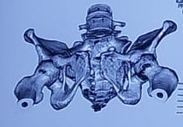 |  | 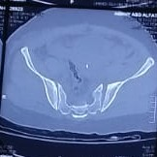 | Figure-11: 3D tomographs after hammock application showing partial reduction and a CT cut showing postereiorly stable sacroiliac joint.
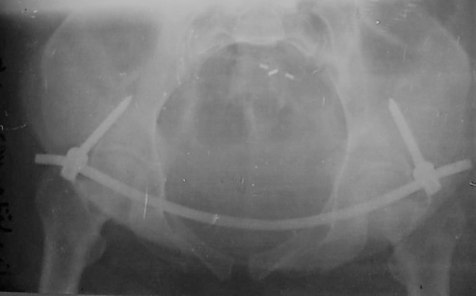 |  | 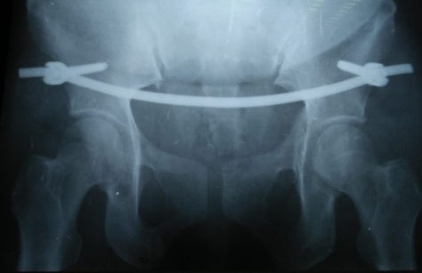 |  | Figure-12: Immediate postoperative radiographs.
 |  |  |  | Figure-13: Inlet and outlet radiographs after 6 monthes showing slight diastasis.

Evaluation of reduction using the criteria of Matta revealed the reduction to be excellent in 4 patients (20%), good in 13(65%), and fair in 3 (15%) patients (table4).
Table -4: Reduction quality, using Matta criteria, distribution.
fracture reduction | No | %
Fair | 3 | 15.0
Good | 13 | 65.0
excellent‎ | 4 | 20.0

The complications encountered in this study included : Infection of spinopelvic occurred in one patient and this was treated by debridement under anathesia and improvement occurs after 3 weeks, Loosening of one screw occurred in one patient and this was observed near time of healing just before removal, Mild infection and this was treated by repeated dressing occurred in one patient, Superfacial infection occurred in two patient and this was treated by antibiotic and serial dressing, Lateral femoral cutaneous neurapraxia occurred in one patient but disappeared spontaneously at postoperatively 1 month and Lateral femoral cutaneous nerve irritation occurred in two patients and this symptom was then relieved gradually and by use of neurotonics and nerve analgesia-completely released after system removal (figure-14). Secondary loss of reduction was recorded in one patient with pure ligamentous injury (figure-13). However, since the patient was free a of any symptoms 6 months postoperatively, the need for a revision surgery with open reduction was excluded.

The implant was removed in all patients guided by findings supporting healing and the severity of the device related symptoms in a mean time of 6 months (4-8). The functional outcome of the INFIX procedure was assessed by the Majeed score (figure-15). The clinical results at the time of removal of the implant were excellent in 5 patients (25%), good in 13 (65%), and fair in 2 (10%). To facilitate calculating a mean figure for Majeed score excellent was given a grade,3, good,2, and fair,1. The mean score in our study was 2.15. The two patients with fair results one of them had intermittent pain at the sacroiliac joint because of the posterior implant.The pain was gradually relieved after removal of the TIFI and the other had body mass index of > 40 kg/m2. Other patients with anterior implants could sit, stand, squat, lie prone and lie on their side normally but 4 patients (20%) had pain during sexual intercourse (table-5). Seventeen patients returned to their pre-injury jobs, while three had to change their jobs involving lighter duties. All patients reintegrated into society without any restrictions.

Figure -15 : Mean figures of Majeed score components and mean grade at end of follow up.

As regards the relation between associated injuries and Majeed score, there was no significant relation (P >0.05). So functional outcome of INFIX was not affected by the presence of associated injuries (table -6).

NO | Pain | sitting | standing | Sexual intercourse | work | total | Grade
1 | 22 | 10 | 28 | 4 | 15 | 79 | Good (2)
2 | 20 | 7 | 28 | 3 | 15 | 73 | Good (2)
3 | 26 | 8 | 23 | 3 | 14 | 74 | Good (2)
4 | 25 | 8 | 27 | 4 | 14 | 78 | Good (2)
5 | 27 | 9 | 26 | 4 | 14 | 80 | Good (2)
6 | 24 | 10 | 31 | 4 | 19 | 88 | Excellent (3)
7 | 28 | 9 | 28 | 4 | 16 | 85 | Excellent (3)
8 | 23 | 8 | 23 | 2 | 13 | 69 | Fair (1)
9 | 24 | 8 | 23 | 3 | 14 | 72 | Good (2)
10 | 27 | 9 | 32 | 4 | 15 | 87 | Excellent (3)
11 | 26 | 8 | 28 | 4 | 16 | 82 | Excellent (3)
12 | 26 | 9 | 24 | 4 | 15 | 78 | Good (2)
13 | 24 | 8 | 29 | 3 | 15 | 79 | Good (2)
14 | 28 | 9 | 26 | 4 | 15 | 82 | Good (2)
15 | 24 | 8 | 23 | 2 | 15 | 72 | Good (2)
16 | 22 | 8 | 22 | 2 | 13 | 67 | Fair (1)
17 | 24 | 8 | 25 | 2 | 13 | 72 | Good (2)
18 | 25 | 9 | 25 | 4 | 14 | 77 | Good (2)
19 | 27 | 8 | 30 | 4 | 15 | 84 | Good (2)
20 | 30 | 10 | 29 | 4 | 16 | 89 | Excellent (3)
Table-5:Details Of Majeed Score

Table -6: Relation between associated injuries and thier effect on the grade of Majeed score
Associated injury | Grade |  |  |  |  |  | X² | P.value
 | Fair n= 2 |  | Good n = 13 |  | Excellent n=5
 | No | % | No | % | No | %
Brain concussion | 0 | 0.0% | 0 | 0.0% | 1 | 20.0% | 37.23 | 0.412
Fibula+rib fracture | 0 | 0.0% | 1 | 7.7% | 0 | 0.0%
Fracture calcaneus | 0 | 0.0% | 1 | 7.7% | 0 | 0.0%
Fracture D7+base skull | 0 | 0.0% | 1 | 7.7% | 0 | 0.0%
Fracture sacrum | 0 | 0.0% | 1 | 7.7% | 0 | 0.0%
L2 compression fracture | 0 | 0.0% | 1 | 7.7% | 0 | 0.0%
Left (LT) radial fracture | 0 | 0.0% | 0 | 0.0% | 1 | 20.0%
Lt humerus fracture | 0 | 0.0% | 1 | 7.7% | 0 | 0.0%
Lt sacroiliac+bil ankle | 0 | 0.0% | 1 | 7.7% | 0 | 0.0%
LT subtrochanteric # | 0 | 0.0% | 1 | 7.7% | 0 | 0.0%
Right (RT) posterior sacroiliac | 1 | 50.0% | 0 | 0.0% | 0 | 0.0%
Rib fracture | 0 | 0.0% | 0 | 0.0% | 1 | 20.0%
Right ulna fracture | 0 | 0.0% | 0 | 0.0% | 1 | 20.0%
RT collis fracture | 0 | 0.0% | 1 | 7.7% | 0 | 0.0%
RT shaft femur | 0 | 0.0% | 1 | 7.7% | 0 | 0.0%
RT hip dislocation | 0 | 0.0% | 1 | 7.7% | 0 | 0.0%
Rupture spleen | 0 | 0.0% | 1 | 7.7% | 0 | 0.0%
Subdural hematoma | 1 | 50.0% | 0 | 0.0% | 0 | 0.0%
None | 0 | 0.0% | 1 | 7.7% | 1 | 20.0%

Table -7: Relation between the surgical procedures used and thier effect on the grade of Majeed score
Surgical procedure | Grade |  |  |  |  |  | X² | P.value
 | Fair |  | Good |  | Excellent
 | No | % | No | % | No | %
INFIX | 1 | 50.0% | 7 | 53.8% | 4 | 80.0% | 15.68 | 0.048
INFIX+interlocking femur nail | 0 | 0.0% | 1 | 7.7% | 0 | 0.0%
INFIX+fixation of distal radius | 0 | 0.0% | 1 | 7.7% | 0 | 0.0%
INFIX+proximal femoral nail | 0 | 0.0% | 1 | 7.7% | 0 | 0.0%
INFIX+plate humerus | 0 | 0.0% | 1 | 7.7% | 0 | 0.0%
INFIX+plate radius | 0 | 0.0% | 0 | 0.0% | 1 | 20%
INFIX+sacroiliac screw | 1 | 50% | 0 | 0.0% | 0 | 0.0%
INFIX+si screw+plate and screws | 0 | 0.0% | 1 | 7.7% | 0 | 0.0%
INFIX+spinopelvic fusion | 0 | 0.0% | 1 | 7.7% | 0 | 0.0%

Regarding the relation between the surgical procedures used and thier effect on the grade of Majeed score, there was significant relation (P<0.05) as some complications that affect some parameters of Majeed score were due to other procedures done additional to INFIX in polytrauma patients and not due to INFIX itself. (table -7)

Discussion:
In this study we used the anterior internal fixator(INFIX) to treat disruptions of the anterior pelvic ring.This study included 20 patients with mean age of 43.5years old with the percentage of male to females 1:1 .
Although the number of cases could be increased to give more accurate results ,it was close to the number of cases of the study of Steer et al (24 patients)(8)
But it was fewer than the number included in the study of Fang et al. (43 patients) (9) And also less than the number of patients in the studies done by Müller et al. (36 patients)(10) and in the study done by Vaidya et al. ( 83 patients).(11).
But it had bigger number of patients than the study done by Rahul et al ( 4 patients). (12) and that done by Bagga et al (3 patients) (13)
In this study The most common cause of injury was motor vehicle accidents (40%) followed by a fall from height (25%).This is in harmony with Steer et al (8)
In this study the mean time from injury to surgery was 7.95 days (3-15) This is near to the time in steer et al study in which it was 5.2 days (0–13). (8)
And the mean of the operation time in this study was 68 minutes. And the average blood loss was 128 ml. But this was more time consumed and more blood loss if this was compared with Xiaotian et al (14) and this might be due to multiple associated injuries in our study as 90 % of the patients in our study had other injuries with additional procedures such as fracture sacrum ,radial fracture and humeral fracture .
In This study fracture reduction was Fair in 3 patients (15%), Good in 13 patients(65%) and excellent in ‎4 patients.(20%) .In comparison with Xiaotian et al in which evaluation by the criteria of Matta showed the reduction was excellent in 12 patients, good in 8, and fair in 3( 14).
Looking for the complications that appeared postoperatively and during follow up period of our patients, bony union was achieved for all pelvic fractures without nonunion or malunion. No heterotopic ossification at the screw heads was observed in our patients. infection of spinopelvic in one patient (5%), lateral femoral cutaneous nerve braxia in one patient (5%), lateral femoral cutaneous nerve irritation in 2 patients (10%), loosening of one screw in 1 patient (5%), mild infection in 1 patient (5%), superfacial infection in 2 patients(10%).In this study Lateral femoral cutaneous neurapraxia occurred in one patient but disappeared spontaneously at postoperatively 1 month.and Lateral femoral cutaneous nerve irritation occurred in two patients and this symptom was then relieved gradually and by use of neurotonics and nerve analgesia-completely released after system removal. this is in harmony with Steer et al (8) and with When Kuttner et al ( 15)
However, this is in contrast with Hesse et al. who reported that resolution of femoral nerve palsy was variable and incomplete despite removal of the implants(16).
In comparison with other studies as Steer et al lateral femoral cutaneous nerve (LFCN) injury, which occurred in 11 patients (bilaterally in two), 6 patients (25%) had ongoing numbness 6 months post removal. Two patients had an infection, one of which prompted the removal of the INFIX. One INFIX was removed for implant failure and heterotopic ossification occurred in five cases (8)
According to Xiaotian et al, The pain decreased with the implant removal. Iatrogenic neuropraxia of unilateral LFCN occurred in 3 patients but disappeared 1 month post surgery. Unilateral femoral nerve palsy was recorded in 1 patient postoperatively 1 day, who was returned to operation emergently for adjustment of the anterior ring fixation. Heterotopic ossification at the screw heads was observed in 8 patients, and were clinically asymptomatic.(14).
But this complication was exaggerated in the study of Hesse et al. which had a femoral nerve palsy in (75%) (16)LFCN irritation occurred in 30% in Vaidya et al study (6)
Hoskins et al. reported an LFCN paralysis rate of 57% in their study (17).In a cadaver study by Reichel et al. comparing the pelvic bridge and INFIX to local anatomic structures, they found the LFCN about 2.2 mm away from the INFIX screw. This explained the high rate of LFCN injury noted by authors.(18).
A systematic review by Vaidya et al. of 496 patients treated with INFIX reported complications including lateral femoral cutaneous nerve (LFCN) injury/irritation (26.3%), heterotopic ossification (36%), infection and wound complications (3%) and femoral nerve palsy (1%). (6).
And in the systematic review done by Kumbhare et al Complications include lateral femoral cutaneous nerve irritation (25.3%), heterotopic ossification (24.7%), infection (3%), and femoral nerve palsy (1.6%); which was related to placing the bar and screws too deep.( 19).
And in comparison with Steer et al 13 LFCNs were affected out of 48 (27%) or 46% of patients initially and Five patients had heterotopic ossification (21%) and two patients had wound issues. (8).
Gardner et al noted LFCN complications in 8.3% . Kuttner et al noted 32% of patients with LFCN problems. Merriman et al performed this in 18 patients and documented 0% LFCN complications. Muller et al noted LFCN complications in 19.4% of patients. Scheyerer et al noted no LFCN complications out of an early report of four patients. (20).
In this study, Majeed score was used as a tool for evaluation of postoperative follow up data 6 months postoperatively and revealed 10% of of our patients had fair, 65% had good, 25% had excellent outcomes . Xiaotian et al reported that clinical outcomes postoperatively ,using the Majeed score, were excellent in 14 patients, good in 7, and fair in 2. (14).
The systematic review by Vaidya et al. found only six articles reporting outcome score for a combined 197 patients. One study used a German pelvic outcome score and the others used the Majeed Pelvic score, with 87 excellent, 77 good and 33 fair results. (6)
All the fractures healed after operation, the average healing time was 12weeks (range, 8-14 weeks) and in comparing with other studies according to radiological healing was as following
Liu (21) | 4.5 ± 1.1 months
Shetty (22) | 3.5 ± 0.75 months
Fang (9) | 14.7 weeks
Removal of the implant in this study was carried out guided by radiological evidence of healing, in fractures, but in ligamentous injury we removed the implant after 6 months based on clinical follow up. Authors removed implants in rather variable timings, as follows:
Vaidya et al. (4) | 3–6 months
Gardner et al. (23) | 4months (2–8 months)
Muller et al. (10) | 9.4 months (27 days- 40.2 months)
Scheyerer et al. (24) | 3- 4 months
Hoskins et al. (17) | 3.6 months

The Systematic Reviews and Meta-analyses done by Kumbhare et al. showed that Fixation with INFIX in these fractures leads to 87% excellent to good radiological results and 84% excellent to good functional results. ( 19).In this study we support the use of INFIX for fixation of anterior ring injuries as with follow up of the patients there was good union ,few complications and good functional outcome
This is in harmony with the the Systematic Reviews and Meta-analyses done by Kumbhare et al. that concluded that the use of INFIX in management of unstable pelvis fractures was required. (19).
And also in harmony with Steer et al that concluded that the pelvic INFIX was a safe and reproducible technique for management of unstable anterior pelvic ring injuries. And this technique is a successful treatment option in more severe pelvic trauma . (8)
And also in harmony with Rahul et al that concluded that The INFIX is a tool to stabilize the pelvis which is stronger than anterior external fixation. (12).
But in contrast with Bagga et al which showed that external fixators are preferred in some scenrios as when surgical field has been contaminated by bowel or bladder content due to visceral injuries, intraabdominal surgical procedures been conducted, or suprapubic catheters are present within the field of potential surgery. (13)
And also in contrast with Owen et al in which single and double rod constructs alone did not maintain adequate fixation. (25).
Despite the satisfactory results that were eventually concluded using INFIX for purely ligamentous injuries, a technique that has not been widely used to the best of the authors’ knowledge, still we believe that plate fixation can yield more reliable fixation as bony union is reasonably stiffer than dense fibrous union achieved by INFIX in these specific injuries.
And also Vigdorchik and Patel et al agreed that anterior plate fixation is stiffer than the INFIX (26,27). And Fang et al concluded in their study that conservative treatment may be more appropriate in stable fractures due to LFCN injury. ( 9)
Finally we do not ignore that this study has a number of limitations that we acknowledge but the most noticed limitation was that it included a small number of patients. Yet we believe that this study provides enough evidence that INFIX application to effective in managing anterior pelvic injuries with a relatively benign set of complications that do not affect the final functional outcomes.

Conclusion:
INFIX technique has good clinical and radiological results obtained in our study, so we believe that this method is an effective alternative for treatment of pelvic ring injuries especially bony ones.

- References:
- (1) Wang, Bi, C, Q, Nagelli, C (2016): Treatment of unstable posterior pelvic ring fracture with pedicle screw-rod fixator versus locking compression plate: a comparative study. Med Sci Monit 22: 3764–3770.
- (2) Zhu, L, Wang, L, Shen, D (2015): Treatment of pelvic fractures through a less invasive ilioinguinal approach combined with a minimally invasive posterior approach. BMC Musculoskeletal Disorders; 16: 167–167.
- (3) Yu, X, Tang, M, Zhou, Z (2013): Minimally invasive treatmentfor pubic ramus fractures combined with a sacroiliac joint complex injury. Int Orthop 37: 1547–1554.
- (4) Vaidya, R, Colen, R, Vigdorchik, J (2012): Treatment of unstable pelvic ring injuries with an internal anterior fixator and posterior fixation: initial clinical series. J Orthop Trauma 26: 1–8.
- (5) Osterhoff G, Tiziani S, Ferguson SJ, et al (2014):Mechanical testing of a device for subcutaneous internal anterior pelvic ring fixation versus external pelvic ring fixation. BMC Musculoskelet Disord. Mar 31;15:111.
- (6) Vaidya R, Woodbury D, Nasr K (2018): Anterior subcutaneous internal pelvic fixation/INFIX. J Orthop Trauma 32, S24–S30.
- (7)Yin, Y., Luo, J., Zhang, R. et al (2019). Anterior subcutaneous internal fixator (INFIX) versus plate fixation for pelvic anterior ring fracture. Sci Rep 9, 2578
- (8) Steer R, Balendra G, Matthews J, et al. (2019): The use of anterior subcutaneous internal fixation (INFIX) for treatment of pelvic ring injuries in major trauma patients, complications and outcomes. SICOT-J 5, 22
- (9) Fang C, Alabdulrahman H, Pape H-C (2017): Complications after percutaneous internal fixator for anterior pelvic ring injuries. Int Orthop (SICOT) 41, 1–6.
- (10) Müller FJ, Stosiek W, Zellner M, et al. (2013): The anterior subcutaneous internal fixator (ASIF) for unstable pelvic ring fractures. Clinical and radiological mid-term results. Int Orthop (SICOT) 37, 2239–2245
- (11) Vaidya R, Martin AJ, Roth M, et al. (2017) Midterm radiographic and functional outcomes of the anterior subcutaneous Internal Pelvic Fixator (INFIX) for pelvic ring injuries. J Orthop Trauma 31, 252–259.
- (12) Rahul Vaidya, Kerellos Nasr, Enrique Feria-Arias,et al (2016) "INFIX/EXFIX: Massive Open Pelvic Injuries and Review of the Literature", Case Reports in Orthopedics, vol. 2016, Article ID 9468285, 7 pages, .
- (13) Bagga, R., Shetty, A. P., Kanna, R. M., et al. (2019). INFIX/EXFIX: Innovation managing pelvic fractures in difficult scenarios. Journal of postgraduate medicine, 65(3), 177.‏
- (14) Xiaotian Wu ., Liu, Z., Fu, W., et al (2017): Modified pedicle screw–rod fixation as a minimally invasive treatment for anterior pelvic ring injuries: an initial case series. Journal of Orthopaedic Surgery and Research, 12(1), 84.‏
- (15) Kuttner M, Klaiber A, Lorenz T, et al. (2009): The pelvic subcutaneous cross-over internal fixator. Der Unfallchirurg 112, 661–669.
- (16) Hesse D, Kandmir U, Solberg B, et al. (2015) :Femoral nerve palsy after pelvic fracture treated with INFIX: A case series. J Orthop Trauma 29, 138–143.
- (17) Hoskins W, Bucknill A, Wong J, et al. (2016): A prospective case series for a minimally invasive internal fixation device for anterior pelvic ring fractures. J Orthop Surg Res 11, 135.
- (18) Reichel LM, MacCormick LM, Dugarte AJ, et al. (2018): Minimally invasive anterior pelvic internal fixation: An anatomic study comparing Pelvic Bridge to INFIX. Injury 49, 309–314.
- (19) Kumbhare c. Meena s. Kamboj k. et al (2020):Use of INFIX for managing unstable anterior pelvic ring injuries: A systematic reviewJournal of Clinical Orthopaedics and TraumaVolume 11, Issue 6, November–December, Pages 970-975
- (20) Apivatthakakul, N. Rujiwattanapong (2016):,“Anterior subcutaneous pelvic internal fixator (INFIX), Is it safe?” A cadaveric study,Injury,Volume 47, Issue 10, ,Pages 2077-2080,ISSN 0020-1383.
- (21) Liu HS, Duan SJ, Liu SD, et al (2018) :Robot-assisted percutaneous screw placement combined with pelvic internal fixator for minimally invasive treatment of unstable pelvic ring fractures. Int J Med Robot Comput Assist Surg 14(5):e1927.
- (22) Ajoy Prasad Shetty, Aju Bosco, Ramesh Perumal, et al (2017):Midterm radiologic and functional outcomes of minimally-invasive fixation of unstable pelvic fractures using anterior internal fixator(INFIX) and percutaneous iliosacral screws,Journal of Clinical Orthopaedics and Trauma,Volume 8, Issue 3.
- (23) Gardner MJ, Mehta S, Mirza A, Ricci WM (2012) :Anterior pelvic reduction and fixation using a subcutaneous internal fixator. J Orthop Trauma 26(5):314–321
- (24) Scheyerer MJ, Zimmermann SM, Osterhoff G, et al. (2014): Anterior subcutaneous internal fixation for treatment of unstable pelvic fractures. BMC Res Notes 7, 1–10.
- (25) Owen, Matthew T. BS, Tinkler, et al ( 2013): Failure and Salvage of “INFIX” Instrumentation for Pelvic Ring Disruption in a Morbidly Obese Patient, Journal of Orthopaedic Trauma: - Volume 27 - Issue 10 - p e243-e246

- (26) Vigdorchik, J. M., Esquivel, A. O., Jin, X., et al (2012). Biomechanical stability of a supra-acetabular pedicle screw internal fixation device (INFIX) vs external fixation and plates for vertically unstable pelvic fractures. Journal of Orthopaedic Surgery and Research, 7(1), 1-6.‏

- (27) Patel, S., Aggarwal, S., Jindal, K. et al. (2021): Outcomes and complications of the INFIX technique for unstable pelvic ring injuries with high-velocity trauma: a systematic review and meta-analysis. Arch Orthop Trauma Surg.

